Graphic Designing & Web Development | Digital Marketing
Hey, this is my portfolio, so I have to say something about myself. I am Freelancer from 3 years in Website Designing and Graphic Designing flied. I have a strong knowledge of web design and development. I am delivering my web designing and graphic designing services as freelancing for a long time. If you require any kind of services, let me know. You can give me the project with full of trust. I have many clients, who trust us. I am 100% sure that my web designing services and graphic designing services will be good for your business.
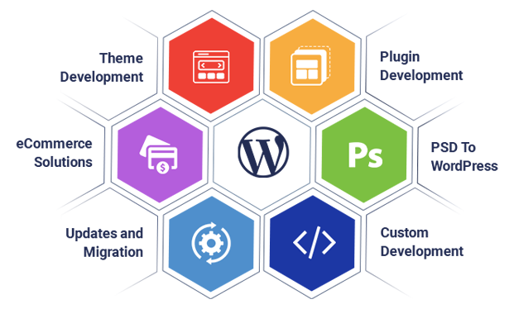

What & Where I Am Providing To The Clients, Here It Goes:
I am a freelancer who is offering every website and graphic designing solutions to the customer in multiple locations such as USA, UK, India, France, Canada, Dubai, and many more countries. There are many things I know to do, to see, and to experience. I know to build and design websites as well as graphic designs.
I have many clients who always see me as the richest experienced and popular web developer. Because I am a very punctual and reliable person in the freelancing industry. I have clients who trust me as well as my web designing services and like them, you can also trust me. I can design the website design, Logo design, banner design, LatterHead, Visiting Card, Phamplate, Menu Card, web site development, WordPress website, eCommerce website, real estate website, travel web development and much more.

